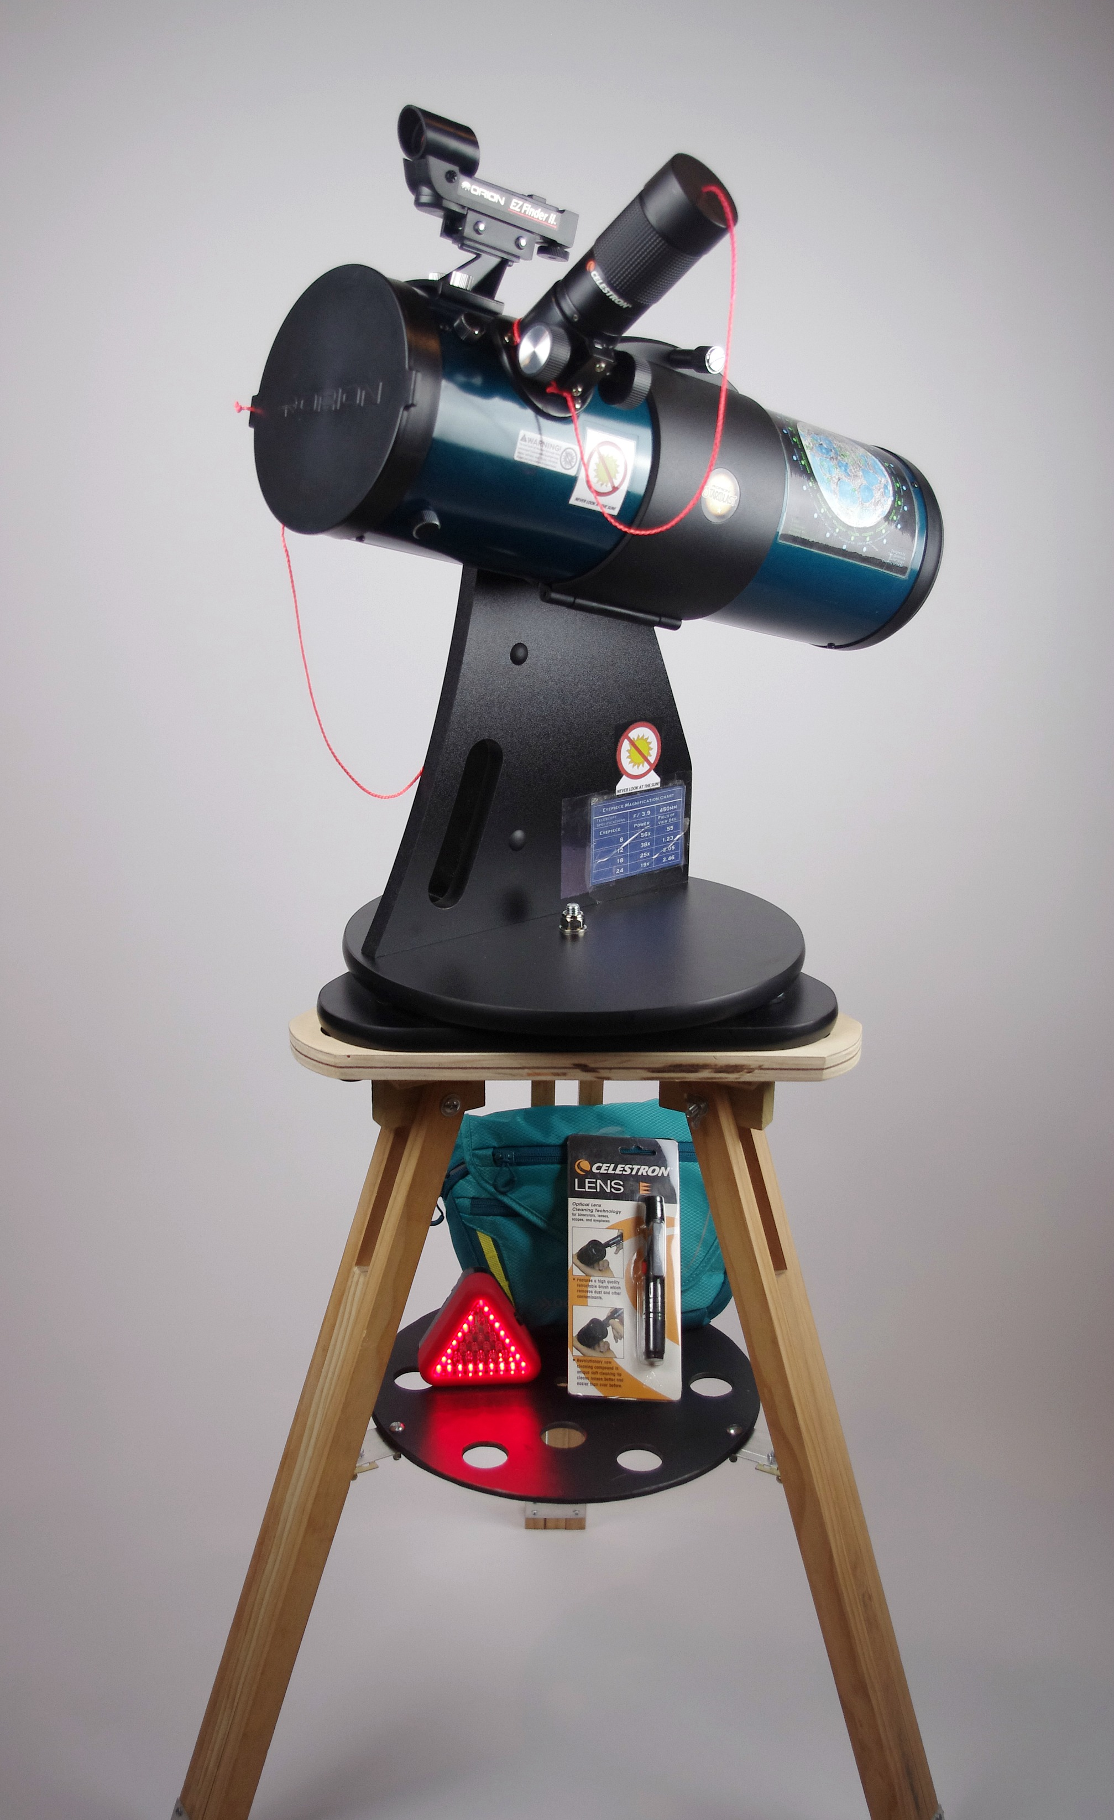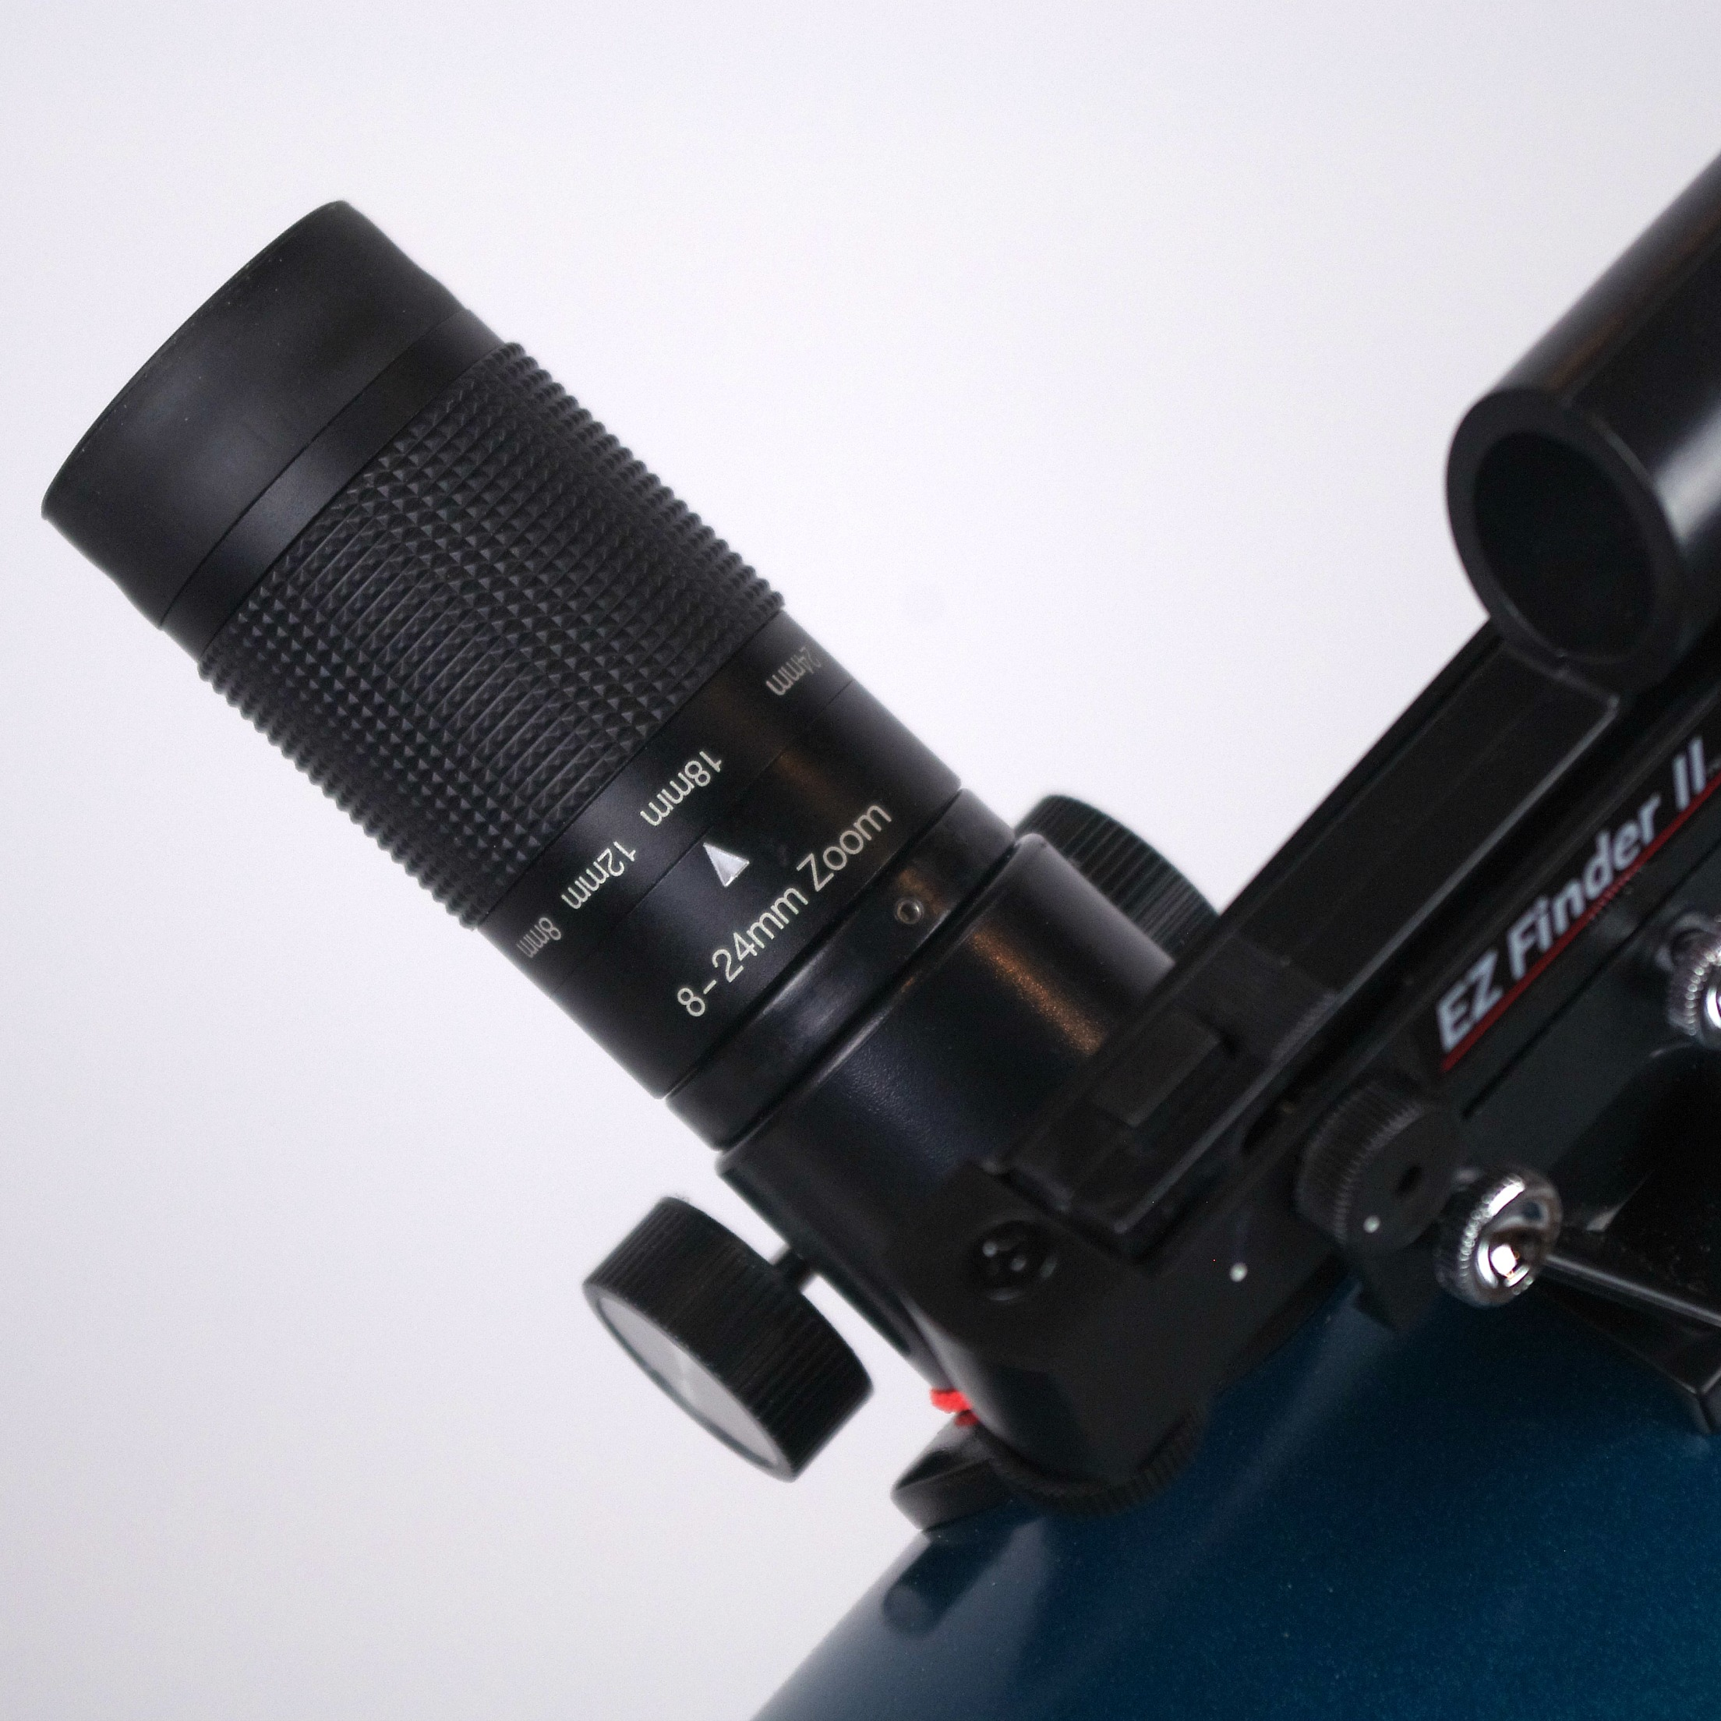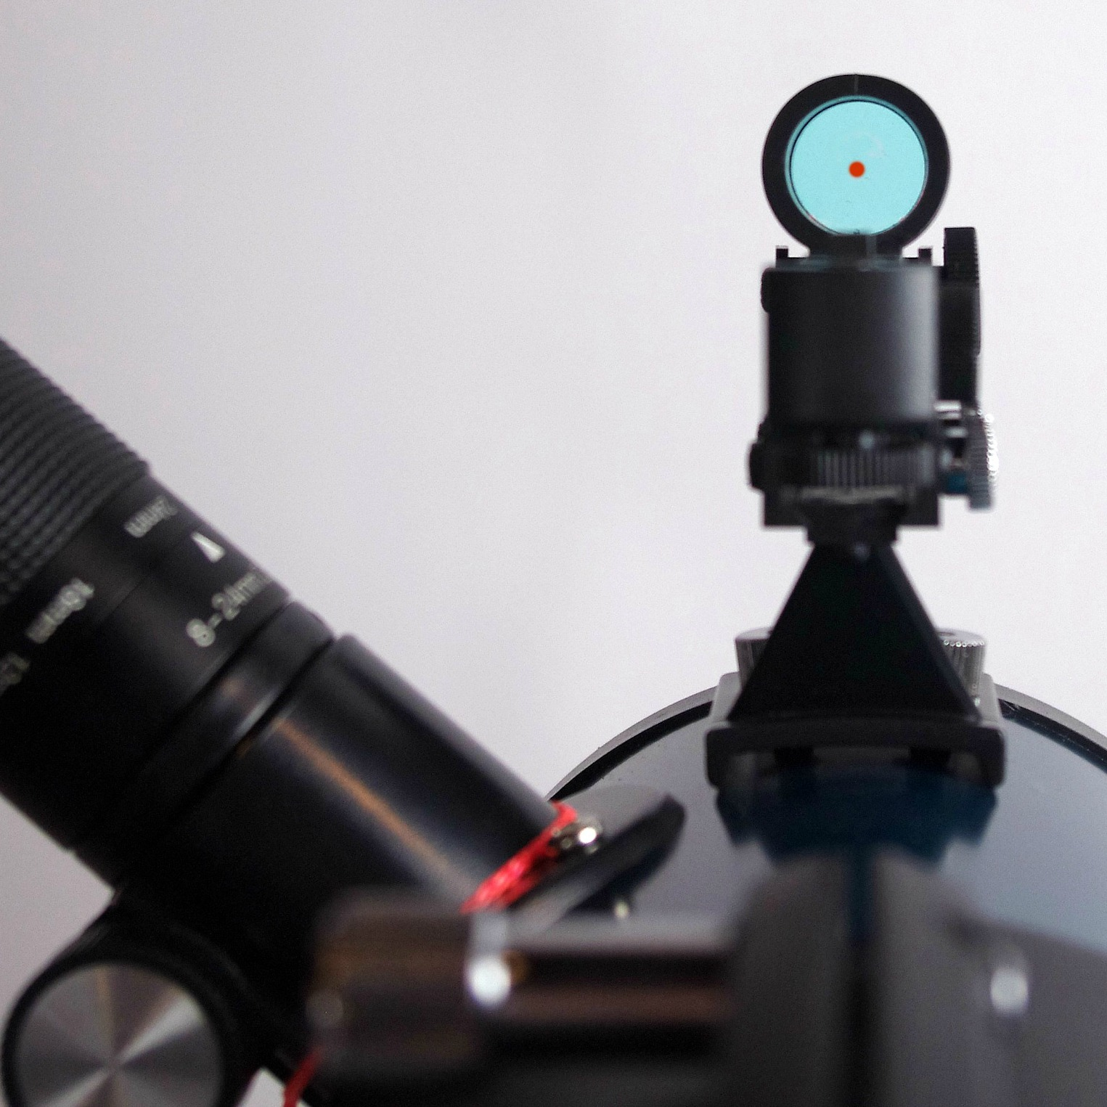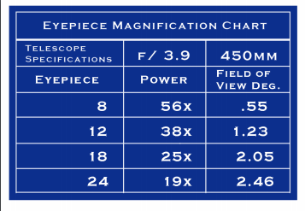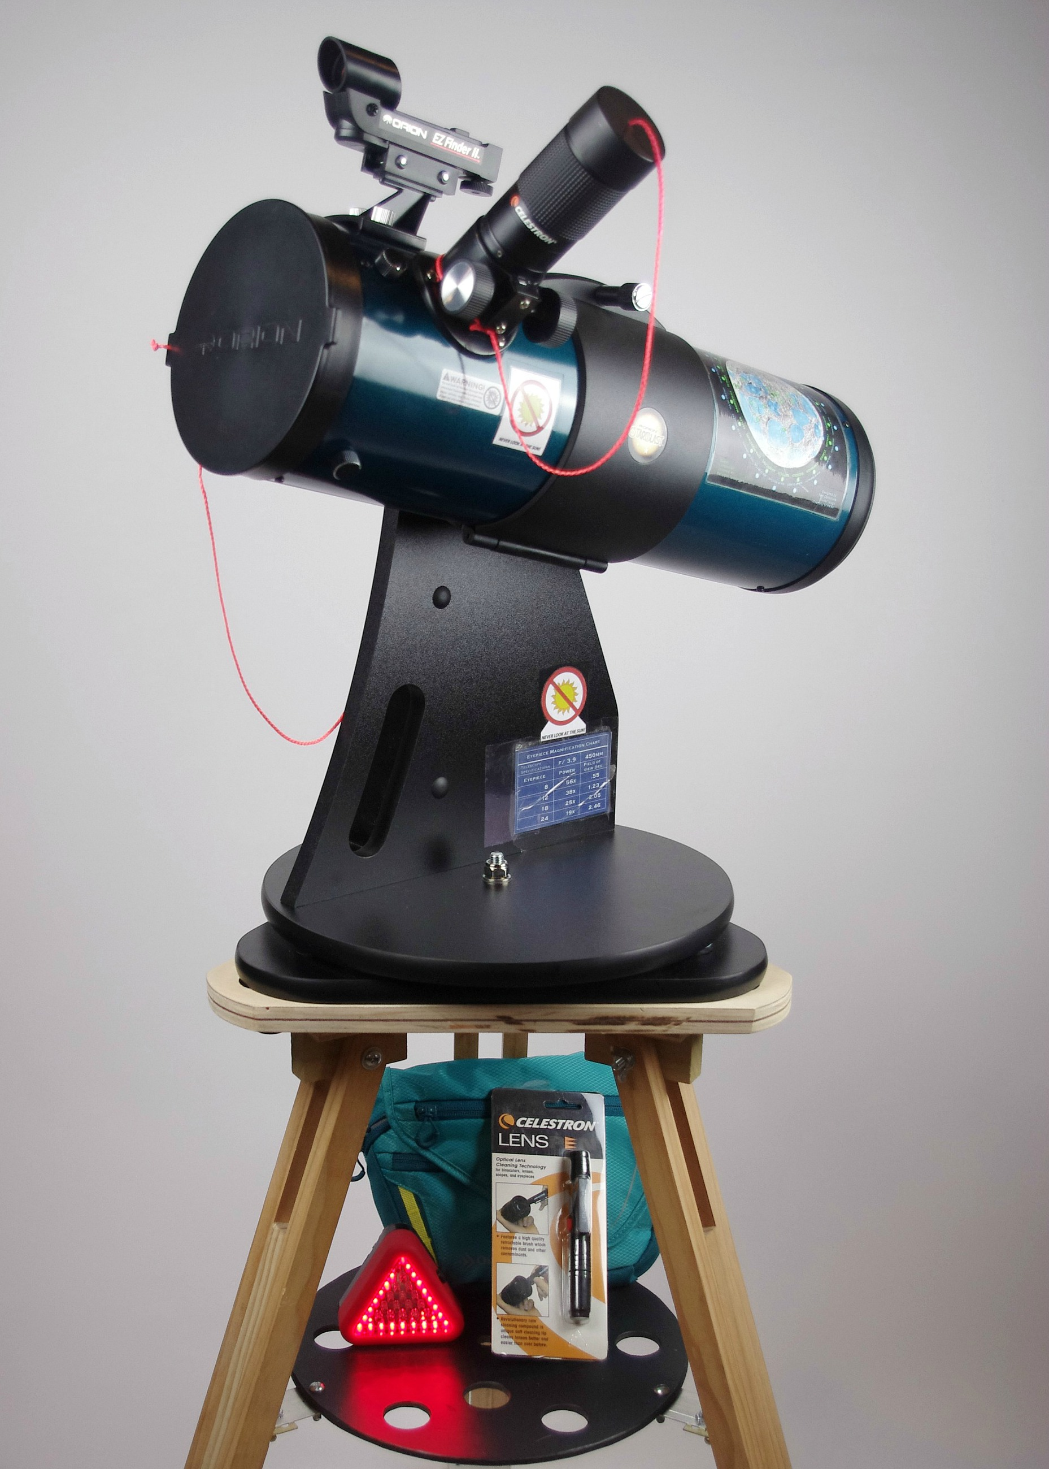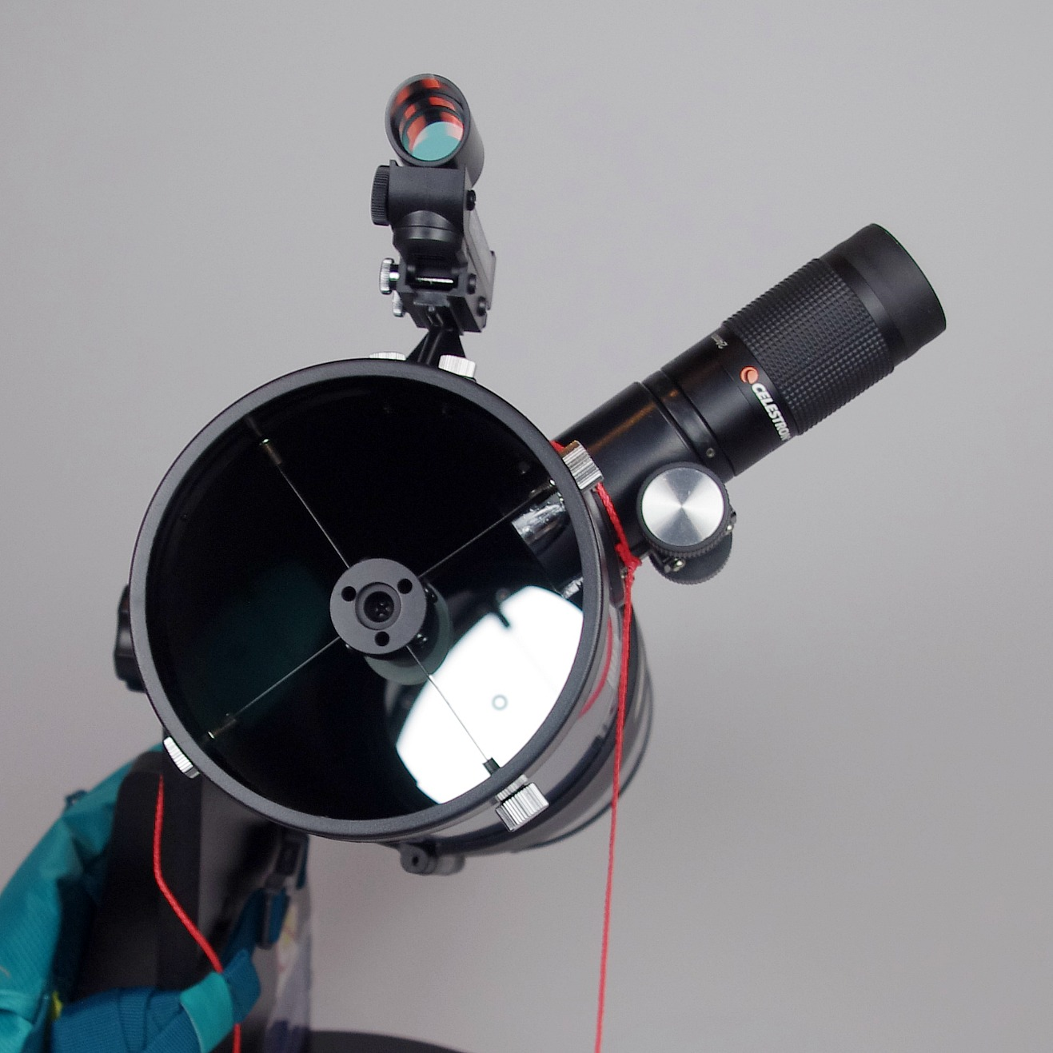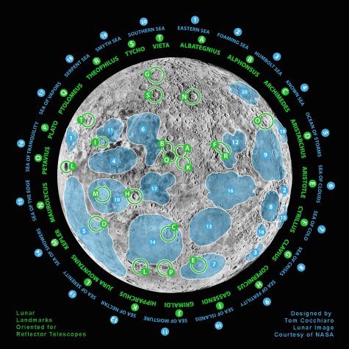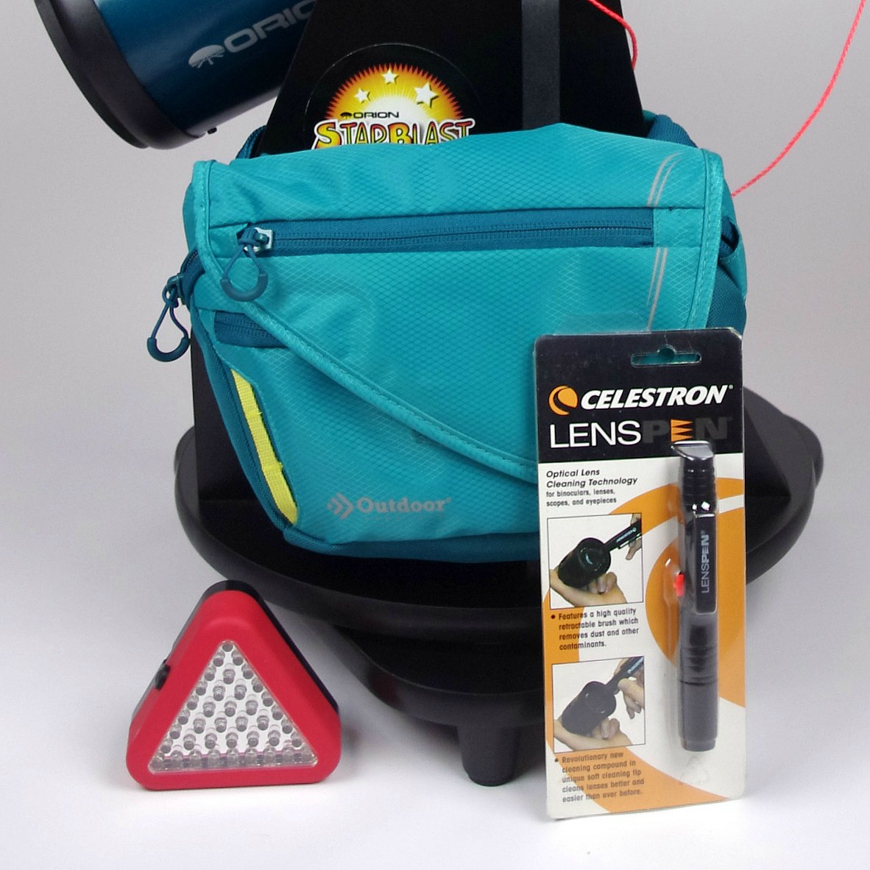

in partnership with the

#### *“Keeping Eyes on*

#### *the Skies”*

#### The Warren Astronomical Society is a 501(c)(3) non-profit organization of amateur astronomers serving the Metro Detroit area. We meet twice monthly indoors for presentations about astronomy and once a month under the stars for observing. Members and the public are invited to attend these events.

#### **Monthly meetings**

#### First Monday @ 7:30pm

#### Cranbrook Institute of Science

#### Third Thursday @ 7:30pm

#### Macomb Community College

#### South Campus- Building J/Library

#### **Observing**

#### Fourth Saturday at dusk

#### Stargate Observatory

#### (located on 29 Mile Road

#### in Ray Township)

#### For more information, visit:

#### http://www.warrenastro.org

#### For information on the Library Telescope Program and how to check out a telescope for personal use, contact any of the following branches below:

#### Woods Branch

#### 20680 Mack Ave.

#### GPW, MI 48236

#### 313-343-2072

#### Central Library

#### 10 Kercheval

#### GPF, MI 48236

#### 313-343-2074

#### Ewald Branch

#### 15175 E. Jefferson

#### GPP, MI 48230

#### 313-821-8830

#### www.gp.lib.mi.us

### **LIBRARY**

### **TELESCOPE**

### **PROGRAM**

presents the

Concept and development of the Library Telescope Program courtesy of:

The New Hampshire Astronomical Society.

www.nhastro.com

Red dot finder to locate and center objects in telescope

**Features of the**

**Orion StarBlast 4.5” Astro Reflector**

**Library Telescope**

Accessory bag includes red night light and lens brush. Not shown, but also included, instructions for telescope and star reference book.

Moon map attached to optical tube to identify lunar features

Dust caps removed from eyepiece and optical tube ready for observing

Magnification chart located on base of telescope

8mm-24mm Celestron zoom eyepiece for wide range of views